
National 4-H Forestry Invitational
Willowbank Building, Room 322
420 Holmes Avenue
Bellefonte, PA 16823

April 7, 2009

To: State 4-H Leaders and State Extension Forestry Program Leaders

Subject: Announcing the 2009 National 4-H Forestry Invitational

Save the date! The 2009 National 4-H Forestry Invitational will be held on July 26-30! Has your state started preparing to send a team to the “Super Bowl of 4-H Forestry”? We’re inviting your state to send a 4-H forestry team to compete this summer at the Invitational. Once again, the Invitational will be held at Jackson's Mill State 4-H Conference Center in Weston, WV. You will find the “Intent to Participate” form attached with this e-mail. If your state has never competed in the Invitational, 2009 would be an excellent opportunity to get your state involved in this exciting event!

One way to find out more about the Invitational is to explore our web site. Check it out! The Handbook and all of the training material necessary for a team to compete in the Invitational can be found on the Invitational’s web site. There is also a slide show from the 2008 Invitational and a video from 2005. Please bookmark this important site:

http://www.aces.edu/N4HFI/

It is suggested that team members and their coach(es) use this web site to prepare for the Invitational. It contains all the information they need to register and train for the Invitational events. Leaders, coaches, and team members can download the Invitational Handbook as well as training reference materials from the web site. Each state should also have a “trunk” that contains many of the materials needed to help your team prepare for the Invitational. Please ask your State 4-H Leader where this trunk has been stored.

This is the 30th year for this national 4-H event. The competition is open to one team of three or four senior 4-H members, or up to two individual members from each state. Participants are selected in a manner determined by your state. If your state does not have a selection method consider assembling a team from interested 4-Hers or perhaps you may have a county with members that could represent your state. Not having a state forestry contest should not deter young people who would like to attend this exciting national 4-H event.

If sending a team is not a possibility this year, the Committee encourages you to send an observer from your state to the Invitational. Funds are available to help offset travel expenses. This is a great way to find out more about the Invitational and experience the excitement of this national competition. For more information on this opportunity please contact me directly.

There are eight distinct parts to the Invitational competition:

Tree Identification Topographic Map Interpretation
Forest Evaluation Forestry Bowl
Tree Measurement Forest Health
Compass and Pacing Forestry Written Examination

Educational events are also provided along with the competition. Participants learn about related environmental subjects, forestry careers, and interact with experienced forestry specialists from many states and professional backgrounds.

The per person cost for attending the Invitational in 2009 will be approximately $126 for the week. This includes all meals and lodging from Sunday evening through Thursday morning. The Invitational Committee is able to cover the cost of each state’s team members lodging and meal expenses through the generous offerings of our sponsor, Farm Credit System (http://www.fcredit.com). A modest travel stipend is also available to help defray the cost of travel to the Invitational at the rate of 15 cents/mile up to $500.00 per team. Only one travel stipend will be awarded per state. Individual 4-H members representing a state unable to send a full team and adult observers from a state not fielding a team will qualify for a similar travel stipend.

The Invitational Committee encourages participation from all states and territories. If your state or territory does not have an active 4-H Forestry program please contact me for information on how the National 4-H Forestry Committee can work with you, your local 4-H leaders, and other volunteers in your state who may be interested in getting a 4-H forestry program started. A state 4-H forestry contest can be as complex or as simple as you desire. Some state forestry contests mimic the Invitational events, but that is not necessary. The important point is we would like to see your state represented at the Invitational and are prepared to help you get 4-H members from your state involved.

To pre-register your state team or your adult observer for the Invitational and be included on the mailing list for competition details, please complete the enclosed “Intent to Participate” form. The form allows you to type on it directly from your computer, save it, and e-mail or print and mail. The e-mail and mail addresses are at the bottom of the form. Please return the form by May 30, 2009.

The 4-H'ers who have participated in past Invitationals have been enthusiastic young men and women. We hope to have the chance to meet your team or your state observer this summer!

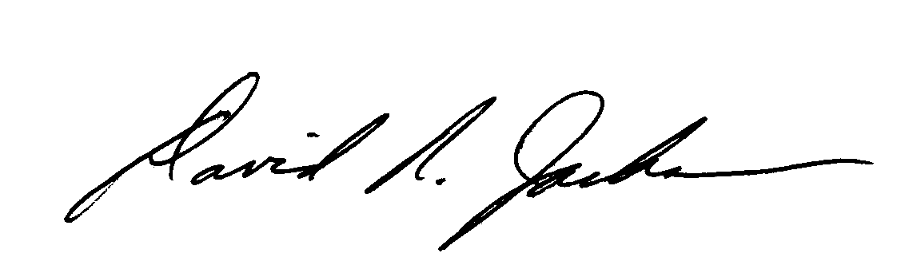
Sincerely,
David R. Jackson
Invitational Chair
814-355-4897
drj11@psu.edu

Enclosure
cc: Invitational Committee

