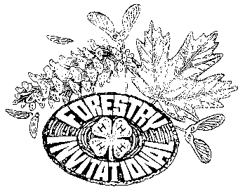
National 4-H Forestry Invitational

July 28, 2011

Contact: David R. Jackson
Penn State Cooperative Extension
Willowbank Building, Room 322
420 Holmes Ave.
Bellefonte, PA 16823
(814) 355-4897

NEWS RELEASE

Georgia Earns Top Score at National 4-H Forestry Invitational

Georgia placed first among the 13 state teams that participated in the 32nd annual National 4-H Forestry Invitational from Sunday, July 24, through Thursday, July 28. Teams from Alabama and Tennessee placed second and third, respectively.

The invitational was held at West Virginia University Jackson’s Mill State 4-H Camp and Conference Center near Weston, West Virginia. The event was sponsored by Farm Credit System, Chesapeake Energy Corporation, The Sustainable Forestry Initiative, Inc., Alpha Natural Resources, West Virginia University Extension Service, and the Association of Natural Resource Extension Professionals.

While at the Invitational 4-H members competed for overall team and individual awards in several categories. Events included tree identification, tree measurement, compass and pacing, insect and disease identification, topographic map use, forest evaluation, the forestry bowl and a forestry written exam.

Georgia was represented by Brittany Evans from Hartwell, Abby Harrison from Royston, Ashley Hollinshead from Lavonia, and Rachel Rice from Hartwell. The team was coached by Charles Rice and Lenora Ramsey both from Hartwell.

Brittany Evans of Georgia received the high point individual award. Second place high individual award was given to Emory Nichols or Alabama and third place high individual award was given to Baylor Nichols of Alabama.

The Joe Yeager Spirit of the Invitational award was given to Rachel Rice of Georgia. This award recognizes an outstanding 4-H contestant at the Invitational. It is presented to the individual who takes initiative, is enthusiastic, and is eager to lead academic and social situations.

4-H is a youth education program operated by the Cooperative Extension Service of the U.S. Department of Agriculture National Institute of Food and Agriculture and the state
land grant universities. More than five-and-a-half million young people participate in 4-H, and nearly 100,000 are part of the 4-H Forestry Program.

The event would not be possible without the generous support of sponsors including; Farm Credit System, Chesapeake Energy Corporation, The Sustainable Forestry Initiative, Inc., Alpha Natural Resources, West Virginia University Extension Service, and the Association of Natural Resource Extension Professionals.

Farm Credit System (FCS) is a government-sponsored enterprise created by Congress in 1916 to provide American agriculture with a dependable source of credit. The FCS is a nationwide network of cooperatively organized banks and associations that are owned and controlled by their borrowers. It serves all 50 States and the Commonwealth of Puerto Rico.

Chesapeake Energy Corporation is one the largest producers of natural gas in the nation and the most active driller of new wells in the U.S. Headquartered in Oklahoma City, the company's operations are focused on discovering and developing unconventional natural gas and oil fields onshore in the U.S.

The Sustainable Forestry Initiative (SFI®), Inc. is a fully independent, charitable organization dedicated to promoting sustainable forest management. The Sustainable Forestry Initiative® label is a sign you are buying wood and paper products from a certified source, backed by a rigorous, third-party certification audit.
Alpha Natural Resources is one of America's top metallurgical coal suppliers, helping to produce steel for growing nations around the globe. Their high-quality coal helps utilities generate electricity more efficiently, while their diverse network of mines and coal preparation plants in the eastern and western U.S. gives them the ability to develop custom blends that suit the specific needs of their customers.
West Virginia University Extension Service educators and volunteers build and help sustain partnerships with people and organizations in West Virginia, to improve their lives and communities. WVU's programs and services strengthen individuals of all ages.

The mission of the Association of Natural Resource Extension Professionals (ANREP) is to bring Extension professionals together to discuss mutual natural resource issues, needs, and opportunities and to advance natural resource Extension through continuing education for Extension professionals.

For more information on the National 4-H Forestry Invitational, go to: http://4hforestryinvitational.org/.

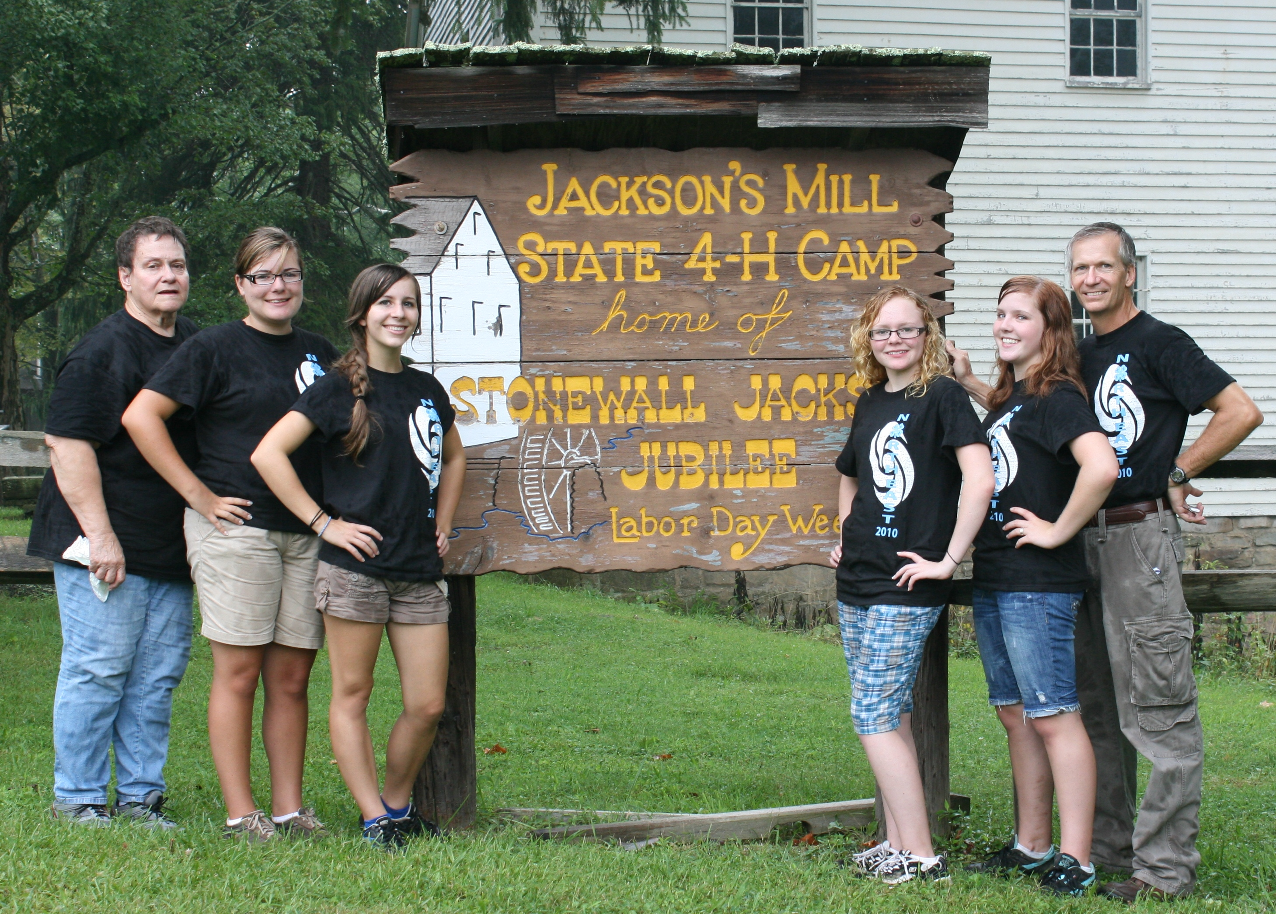

GEORGIA
Left to Right: Assistant Coach/Chaperone Lenora Ramsey, Team Members: Ashley Hollinshead, Rachel Rice, Brittany Evans, Abby Harrison, and Coach Charles Rice.

