July 30, 2009

Contact: David R. Jackson
Penn State Cooperative Extension
Willowbank Building, Room 322
420 Holmes Ave.
Bellefonte, PA 16823
(814) 355-4897

NEWS RELEASE

Alabama Earns Top Score at National 4-H Forestry Invitational

Alabama placed first among the 14 state teams that participated in the 30th annual National 4-H Forestry Invitational from Sunday, July 26, through Thursday, July 30. Teams from Illinois and Louisiana placed second and third, respectively.

At the Invitational 4-H members compete for overall team and individual awards in several categories. Events included a forestry written exam, tree identification, tree measurement, compass and pacing, insect and disease identification, topographic map use, the forestry bowl and forest evaluation.

The invitational was held at West Virginia University Jackson’s Mill State 4-H Camp and Conference Center near Weston, West Virginia. The Farm Credit System and the Cooperative Extension Service sponsored the event.

Alabama was represented by Tamara Beams and Amelia DeWitt from Northport, and Forrest Ford and Hunter Ford from Tuscaloosa. The team was coached by Wayne Ford.

Forrest Ford of Alabama received the high-point individual award. Second place high individual award was given to Amelia DeWitt of Alabama and third place high individual award was given to Amber Jenkins of Georgia.

The Joe Yeager leadership award was given to Wilson Pierce of Georgia. This award is presented to the individual who demonstrated excellent communication, management, decision-making and interpersonal skills at the Invitational.

4-H is a youth education program operated by Cooperative Extension Service of the U.S. Department of Agriculture and the state land grant universities. More than five-and-a-half million young people participate in 4-H, and nearly 100,000 are part of the 4-H Forestry Program.

This event is sponsored by the Farm Credit Systems (FCS), a government-sponsored enterprise created by Congress in 1916 to provide American agriculture with a dependable source of credit. The FCS is a nationwide network of cooperatively organized banks and associations that are owned and controlled by their borrowers. It serves all 50 States and the Commonwealth of Puerto Rico. The FCS provides credit and other services to agricultural producers and farmer-owned agricultural and aquatic cooperatives.

For more information on the National 4-H Forestry Invitational, go to: http://www.aces.edu/n4hfi.

Alabama

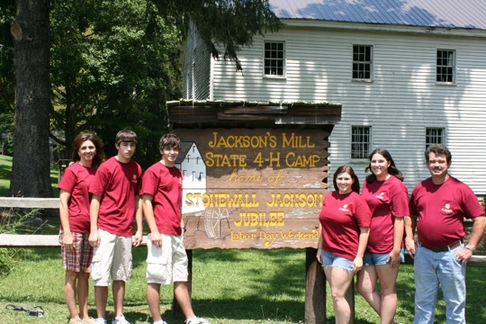

Left to right: Lisa Ford, Hunter Ford, Forrest Ford, Amelia Dewitt, Tamara Beams, S. Wayne Ford

